Google Authentication (OAuth 2.0)

1. What is Google Authentication?
Google Authentication allows users to log in to an application using their Google account instead of creating a new username and password.
It is based on the OAuth 2.0 authorization framework, which enables secure access to user information without sharing the user's password with the application.
This process improves security, convenience, and user experience.

Google Authentication Setup in Google Console
Step 1: Open Google Cloud Console
- Go to the Google Cloud Console
- Login with your Google account.
Purpose:
This platform allows developers to manage APIs, authentication, and cloud services.
Step 2: Create a New Project
- Click Select Project at the top.
- Click New Project.
- Enter:
  - Project Name
  - Organization (optional)
Example:
Project Name: AI Resume Generator
- Click Create.

Purpose:
A project groups all APIs and authentication settings for your application.
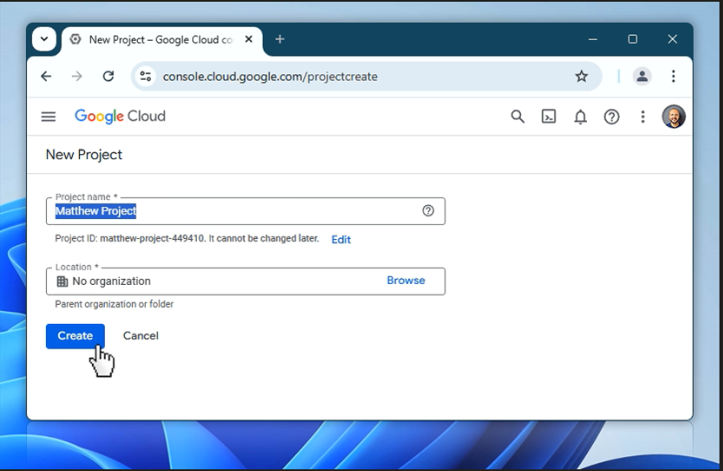
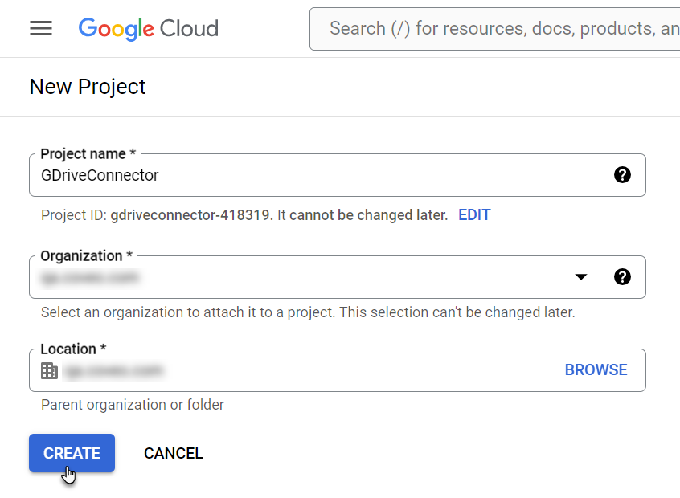
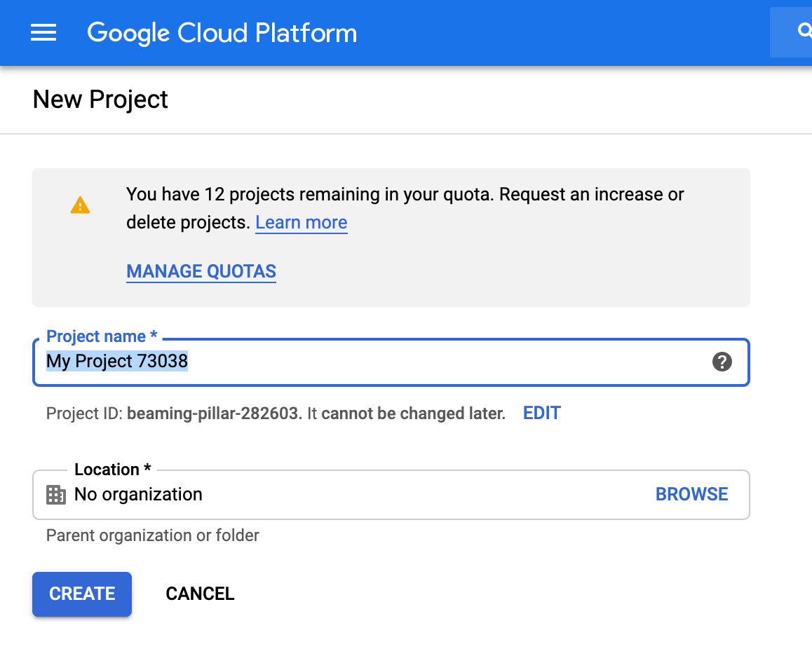

Step 3: Enable Google Identity API
Steps
- In the left menu click APIs & Services.
- Click Library.
- In the search bar type Google Identity or Google OAuth.
- Select the API.
- Click Enable.
Purpose
Enabling the API allows your application to communicate with Google’s authentication service so users can sign in using their Google accounts.
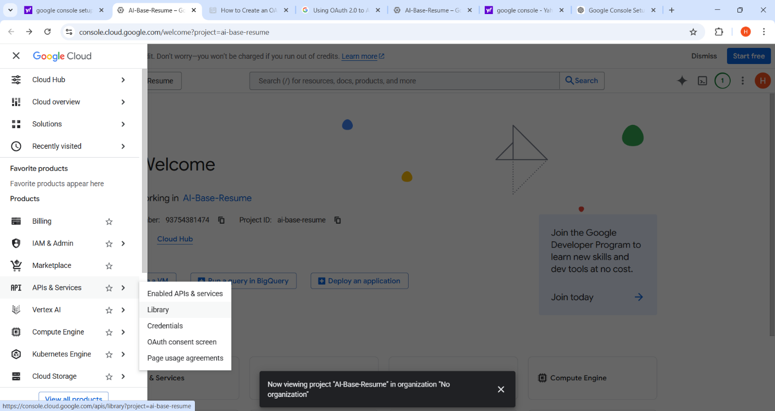
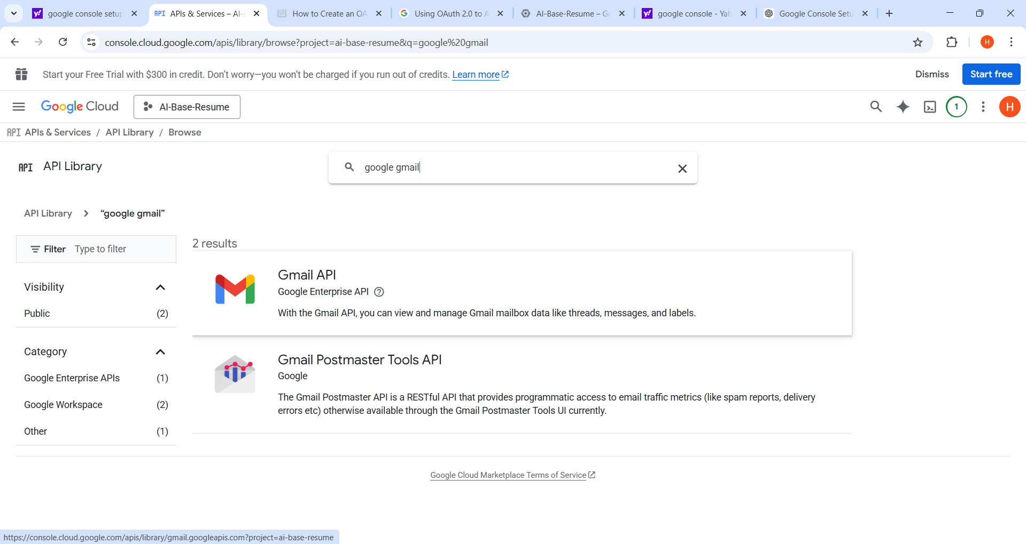
Step 4: Configure OAuth Consent Screen
Steps
- Go to APIs & Services → OAuth consent screen.
- Choose External (for testing with Google accounts).
- Click Create.
Fill in the details:
- App Name: AI Resume Generator
- User Support Email: your Gmail
- Developer Contact Email: your Gmail
Click Save and Continue
Purpose
The OAuth consent screen informs users what application is requesting access and what information will be shared, such as their email and profile details.
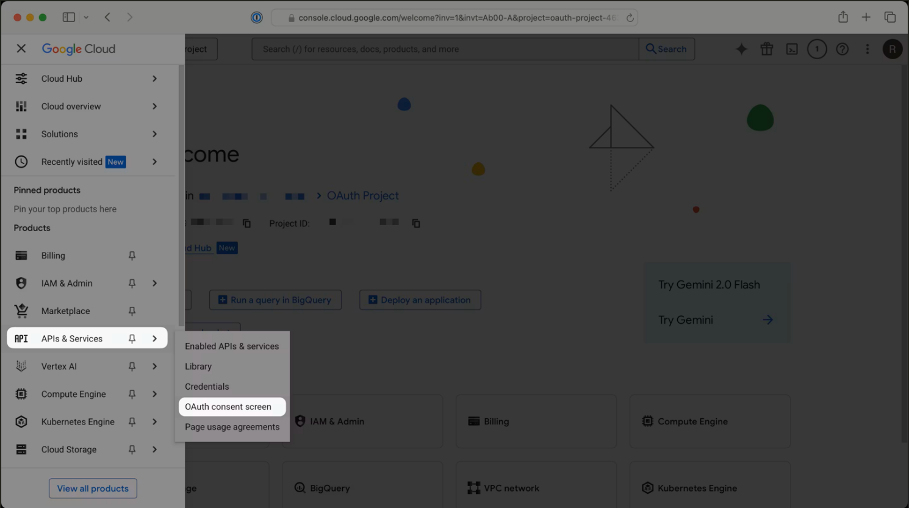
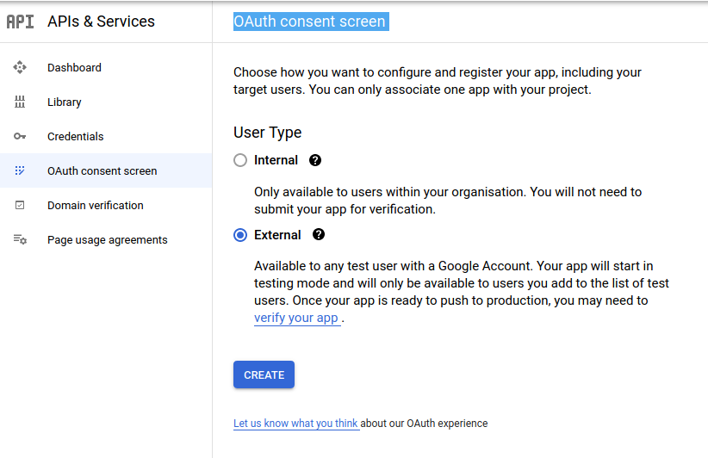

Step 5: Add Test Users
Steps
- In the Test Users section click Add Users.
- Enter your Gmail address.
- Click Save.
Purpose
While the application is in testing mode, only the added test users can log in using Google authentication.
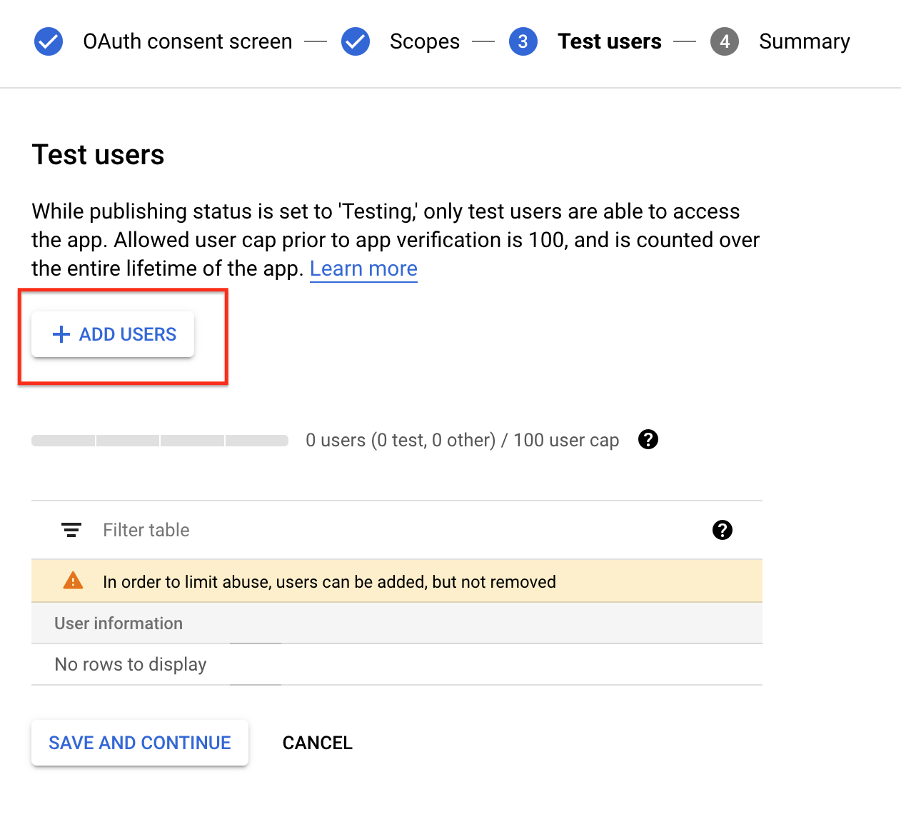
Step 6: Create OAuth Client ID
Steps
- Go to APIs & Services → Credentials.
- Click Create Credentials.
- Select OAuth Client ID.
- Choose Application Type: Web Application.
Purpose
The OAuth Client ID uniquely identifies your application when communicating with Google’s authentication servers.
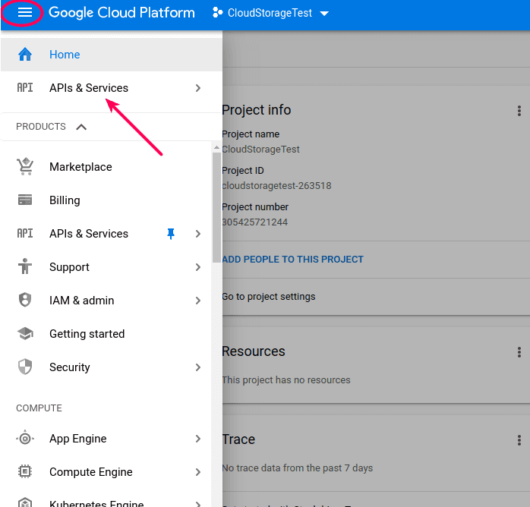
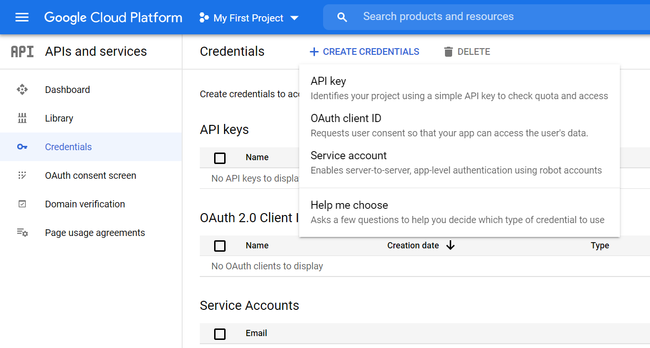

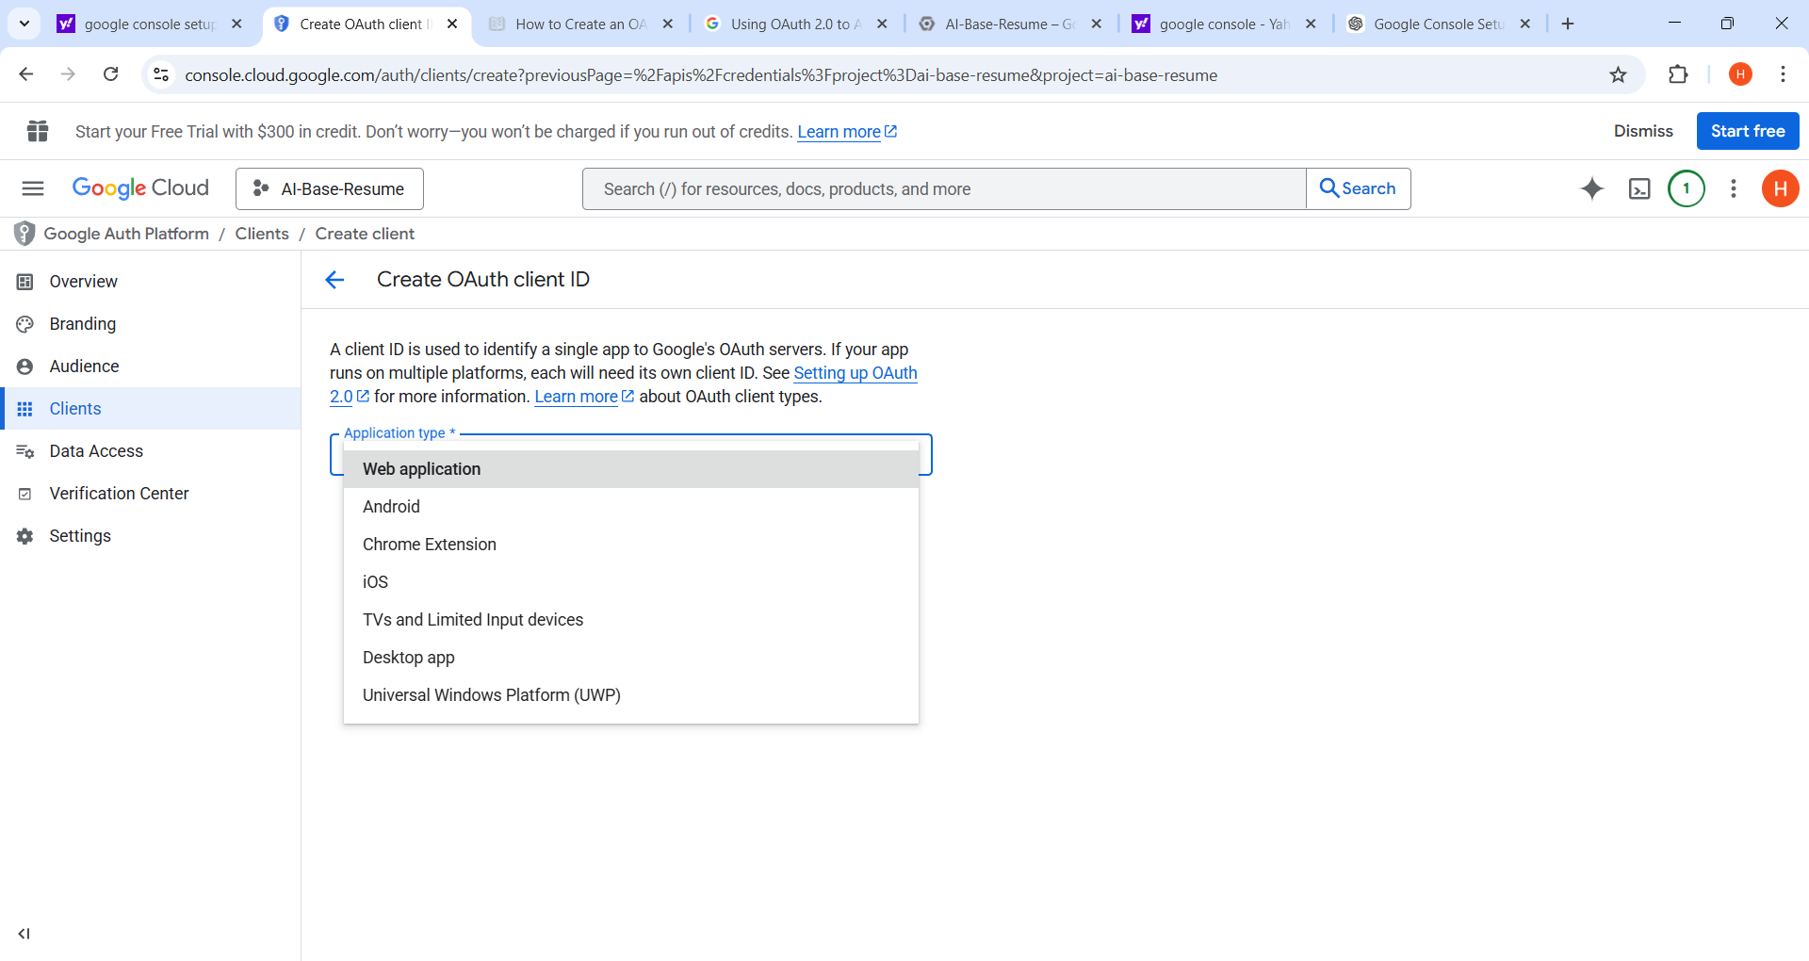

Step 7: Add Authorized Redirect URI
Steps
Add the redirect URL used in your FastAPI application.
Example:
http://127.0.0.1:8000/auth
or
http://localhost:8000/auth
Then click Create.
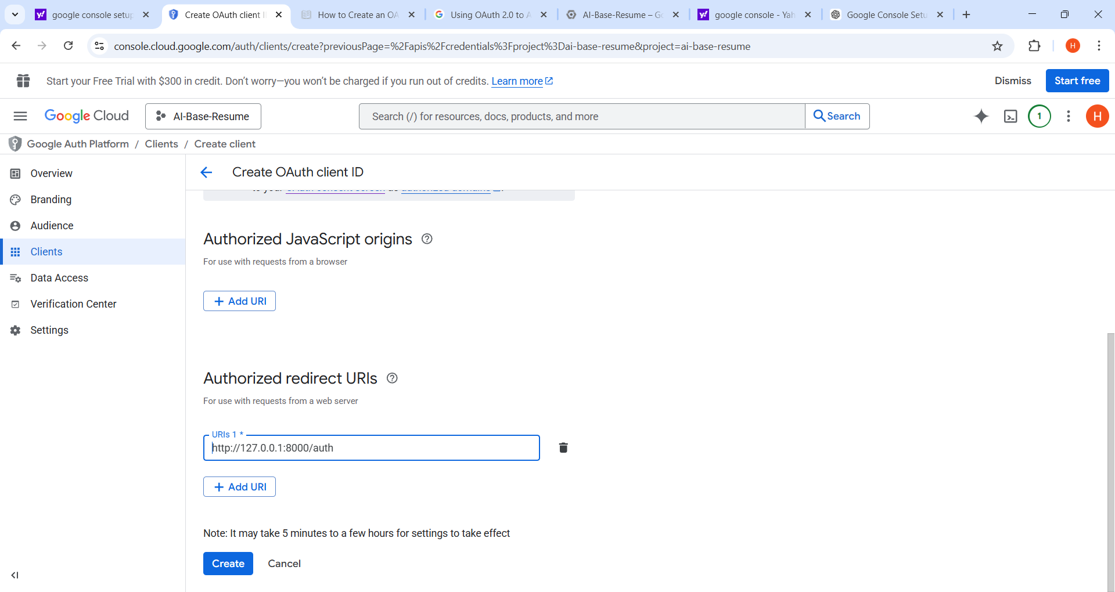
Purpose
After a user successfully logs in with Google, Google sends the authentication response back to this redirect URI, where your FastAPI backend processes the login.
Step 8: Copy Client ID and Client Secret
After creating the OAuth client, Google will generate:
- Client ID
- Client Secret
Example:
Client ID: xxxxxxxxx.apps.googleusercontent.com
Client Secret: GOCSPX-xxxxxxxx
Purpose
These credentials allow your application to securely request authentication and verify its identity with Google.
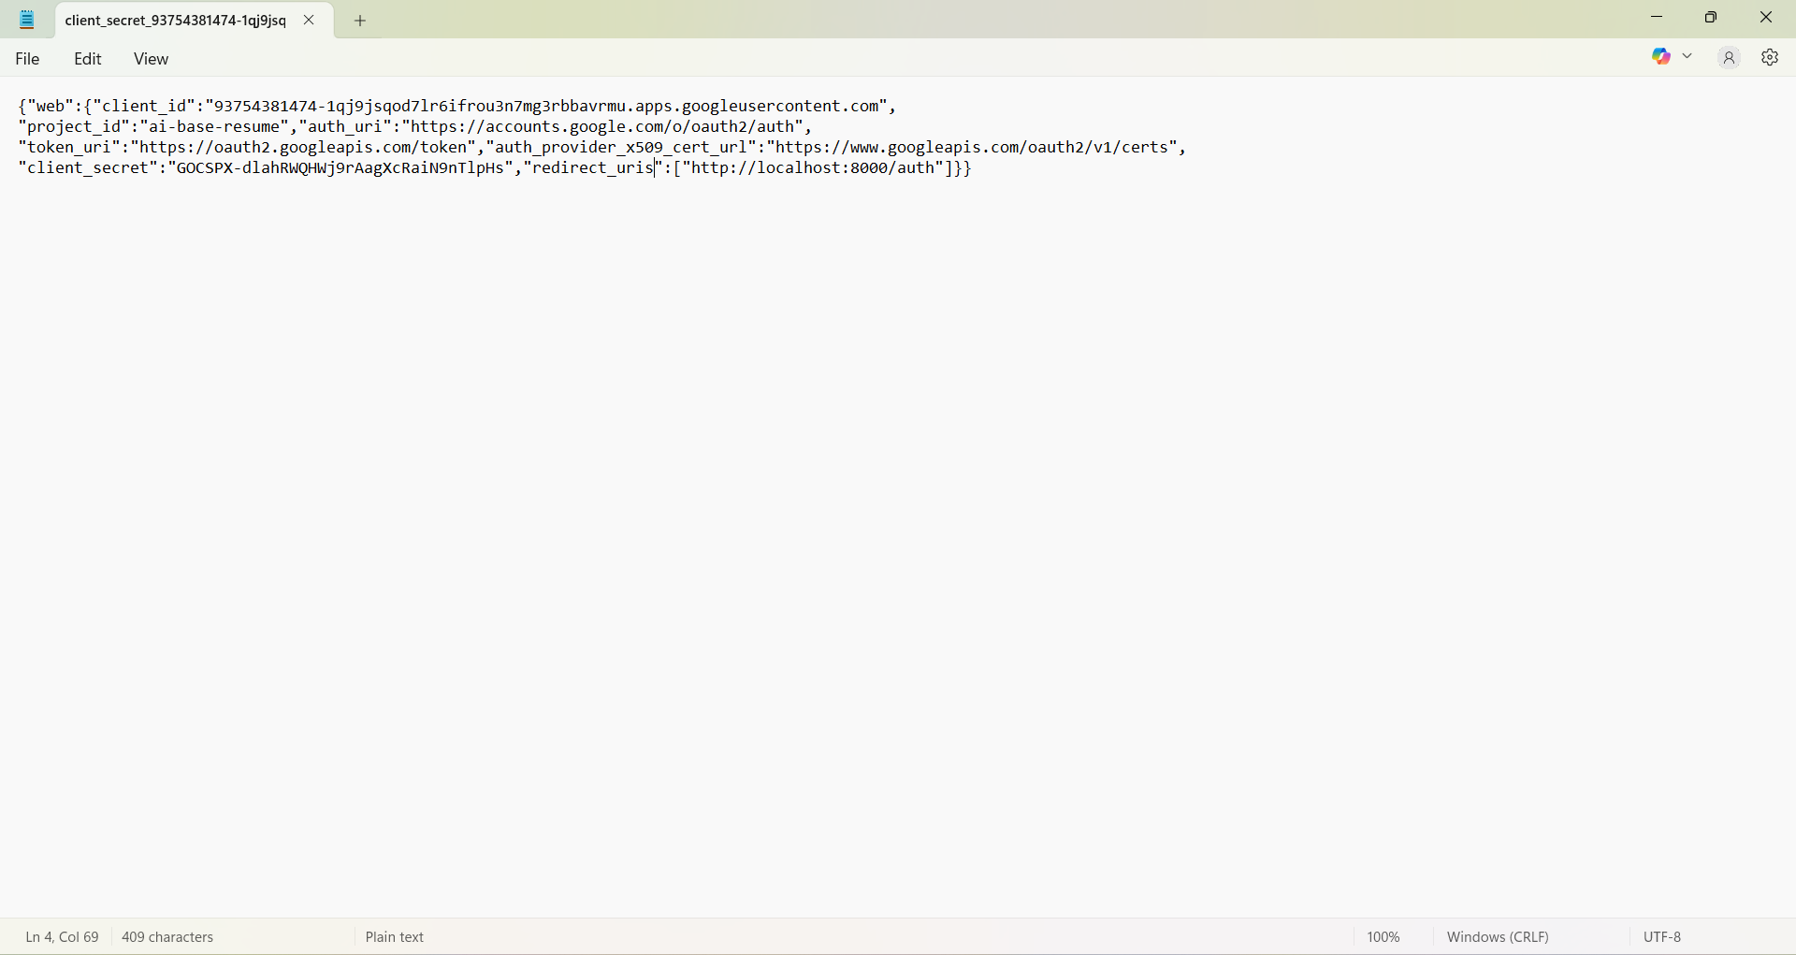
Step 9: Add Credentials to Your Project
Store the credentials in a .env file in your FastAPI project.
Example:
GOOGLE_CLIENT_ID=your_client_id
GOOGLE_CLIENT_SECRET=your_client_secret
REDIRECT_URI=http://127.0.0.1:8000/auth
Purpose
Using environment variables helps protect sensitive credentials and keeps them separate from the main source code.
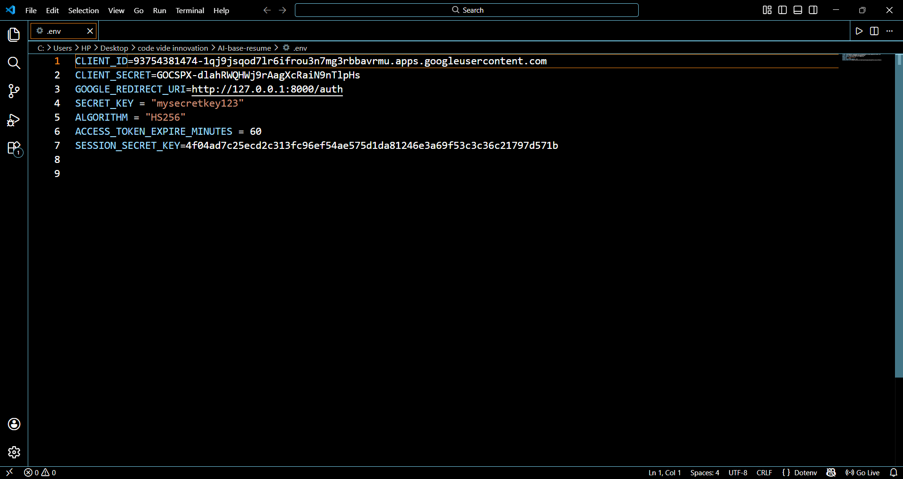

Three Main Steps
Step 1 — Login Request
User clicks:
Sign in with Google
Application redirects to Google.
Step 2 — Google Authentication
User logs into Google and allows permissions.
Google sends authorization code.
Step 3 — Callback Processing
Application:
- Receives authorization code
- Exchanges it for access token
- Retrieves user information
- Logs in the user

THE PROJECT SETPS
1. Create .env File
The .env file is used to store sensitive configuration information such as API keys, client IDs, and secret keys. These values should not be written directly in the code because it can create security risks.
Using an .env file helps to keep the credentials secure and allows the project configuration to be easily changed without modifying the main program.
In this project, the .env file contains:
- Client ID – Unique identifier provided by Google for the application.
- Client Secret Key – Used to authenticate the application with Google.
- Redirect URL – The URL where Google sends the user after successful authentication.
Example .env file:
GOOGLE_CLIENT_ID = your_google_client_id
GOOGLE_CLIENT_SECRET=your_google_secret_key
REDIRECT_URI=http://localhost:8000/auth/callback
SECRET_KEY=your_secret_key
- Protect sensitive data
- Manage environment variables
- Improve security of the application

2. Create auth.py File
The auth file is responsible for authentication-related functions such as password hashing and password verification.
Passwords should never be stored in plain text inside a database. Instead, they must be hashed (encrypted) using secure algorithms. When a user logs in, the system verifies the entered password with the stored hashed password.
Common libraries used:
- passlib
- bcrypt
Example functions:
from passlib.context import CryptContext
pwd_context = CryptContext(schemes=["bcrypt"], deprecated="auto")
def hash_password(password: str):
return pwd_context.hash(password)
def verify_password(plain_password, hashed_password):
return pwd_context.verify(plain_password, hashed_password)
- Secure password storage
- Prevent password leaks
- Improve authentication security

3. Create auth_config.py File
The auth_config file is used to load configuration values from the .env file and make them accessible to the application.
This file ensures that environment variables such as client ID, client secret, and redirect URL are properly loaded into the system.
Usually, the python-dotenv library is used to load .env variables.
Example:
from dotenv import load_dotenv
import os
load_dotenv()
GOOGLE_CLIENT_ID = os.getenv("GOOGLE_CLIENT_ID")
GOOGLE_CLIENT_SECRET = os.getenv("GOOGLE_CLIENT_SECRET")
REDIRECT_URI = os.getenv("REDIRECT_URI")
SECRET_KEY = os.getenv("SECRET_KEY")
- Load environment variables
- Centralize authentication configuration
- Make credentials accessible in the project

4. Write Functions in main.py
The main file contains the main FastAPI application and handles the Google OAuth authentication flow.
Two main functions are implemented:
Google Login Function
This function redirects the user to the Google login page.
The user enters their Google credentials and grants permission to the application.
Example flow:
- User clicks Login with Google
- Application sends request to Google OAuth server
- Google asks user to authorize the app

Google Auth Callback Function
After the user logs in successfully, Google redirects the user to the callback URL defined in the .env file.
- Receives the authorization code from Google
- Exchanges the code for an access token
- Uses the access token to retrieve the user’s profile information
Example steps:
- Google sends authorization code
- Application exchanges code for access token
- Application retrieves user email and profile
- User is logged into the system
Example structure:
@app.get("/login/google")
async def google_login():
return await oauth.google.authorize_redirect(request, REDIRECT_URI)
@app.get("/auth/callback")
async def auth_callback():
token = await oauth.google.authorize_access_token(request)
user = await oauth.google.parse_id_token(request, token)
return user
- Handle Google authentication
- Receive user information
- Allow secure login without manual registration

Common Google OAuth Errors and Fixes

1. Access Blocked – This App’s Request Is Invalid
Error Message
Access blocked: This app’s request is invalid
Error 400: invalid_request
This error usually occurs when the OAuth consent screen is not configured properly or the user is not authorized to test the application.
Common reasons:
- OAuth Consent Screen not completed
- Test user not added
- Missing required OAuth parameters
Fix
- Open Google Cloud Console.
- Go to APIs & Services → OAuth Consent Screen.
- Fill all required details:
  - App name
  - User support email
  - Developer contact information
- Scroll to Test Users section.
- Click Add Users.
- Enter the Gmail address that will test the application.
- Save changes.
Explanation
Google blocks the authentication request if the application is not verified or the user is not added as a test user. Adding the user allows them to access the app during development.

2.Redirect URI Mismatch
Error 400: redirect_uri_mismatch
The Redirect URI sent by the application does not match the Redirect URI registered in Google Cloud Console.
Example:
Application Redirect URI:
http://localhost:8000/auth/google/callback
Google Console Redirect URI:
http://localhost:8000/callback
Since both are different, Google throws this error.
Fix
- Open Google Cloud Console.
- Go to APIs & Services → Credentials.
- Click your OAuth 2.0 Client ID.
- Find Authorized Redirect URIs.
- Add the exact URI used in your application.
Example:
http://localhost:8000/auth/google/callback
- Save the changes.
Explanation
Google OAuth requires the exact redirect URI match for security reasons to prevent unauthorized redirection attacks.

3. Error: Invalid Client ID
Error 401: invalid_client
This happens when the Client ID or Client Secret is incorrect.
Common reasons:
- Wrong Client ID copied
- Using credentials from another project
- Client Secret missing
Fix
- Open Google Cloud Console.
- Go to APIs & Services → Credentials.
- Copy the correct:
  - Client ID
  - Client Secret
- Update them in your application configuration.
Example configuration:
CLIENT_ID=xxxxxxxxxxxx.apps.googleusercontent.com
CLIENT_SECRET=xxxxxxxxxxxxx
Explanation
Google verifies the Client ID and Client Secret to confirm the application's identity before allowing authentication.
4. Error: Invalid Scope
Error 400: invalid_scope
The application requests a scope that Google does not support.
Example wrong scope:
https://www.googleapis.com/auth/user.email
Correct scope:
https://www.googleapis.com/auth/userinfo.email
Fix
Use valid scopes such as:
openid
https://www.googleapis.com/auth/userinfo.profile
https://www.googleapis.com/auth/userinfo.email
Explanation
Scopes define what user data the application can access. Invalid or unsupported scopes cause authentication failure.

5.Error: Access Denied
Error: access_denied
Cause
The user denied permission during the Google login process.
Fix
- Ask the user to allow permission during login.
- Ensure correct scopes are requested.
Explanation
Google requires user consent before sharing profile information with an application.

Internal Server Errors
1. 500 – Internal Server Error
Error Message
500 Internal Server Error
Explanation
This error occurs when the server encounters an unexpected condition that prevents it from completing the request. It means the problem is on the server side, not the user’s browser.
Common Causes
- Bug or error in backend code
- Database connection failure
- Server misconfiguration
- Missing environment variables (like CLIENT_ID or SECRET)
Example
In a FastAPI OAuth project, if the server tries to access a database but the database is not running, the server may return a 500 Internal Server Error.
Fix
- Check server logs
- Debug backend code
- Ensure database and API services are running
- Verify environment variables

2.503 – Service Unavailable
Error Message
503 Service Unavailable
Explanation
This error occurs when the server is temporarily unable to handle the request, usually because it is overloaded or under maintenance.
Common Causes
- Server overload
- Maintenance mode
- Too many requests
Example
If a website receives too many authentication requests at the same time, the server may temporarily return 503 Service Unavailable.
Fix
- Restart the server
- Increase server resources
- Implement load balancing

